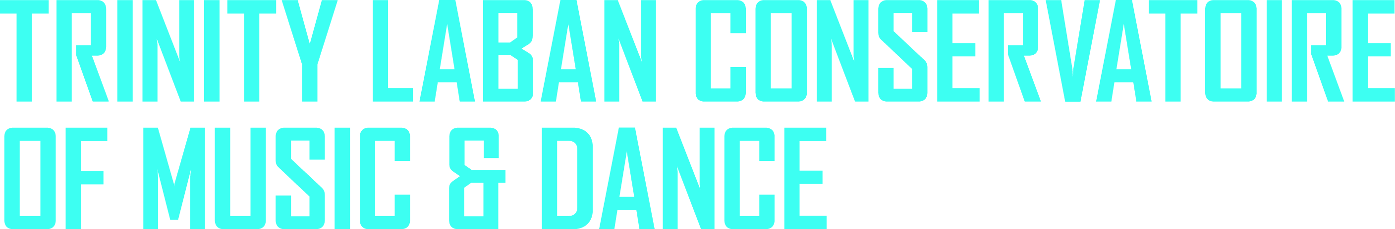

CONTEMPORARY DANCE AUDITION
To register please fill in this form and send it to rome@trinitylaban.ac.uk

Your details
Name |  | Surname
Postal address

Email address
Name of your current school/college/university

Workshop details
Programme you would like to apply for

How did you hear about the weekend workshop and audition?

How did you hear about Trinity Laban?

